Raster (Bitmaps) VS Vector Designs
Vector Design: It is a mathematical defined line or curve. Vectors are used to define objects typified by line art. It can be arbitrarily scaled without losing detail. Illustrator images are examples of vector images.
Raster Image (Bitmap): A grid into which the pixels are arranged. Images made up of pixels are referred to as raster images .Raster images cannot be enlarged without the pixels becoming visible
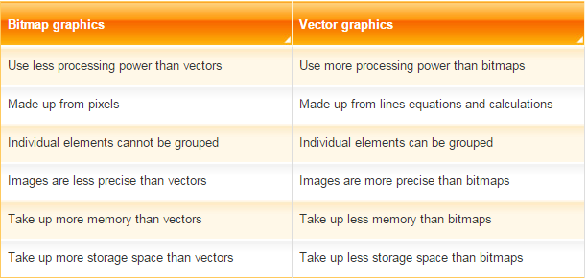

Bitmap | Vector
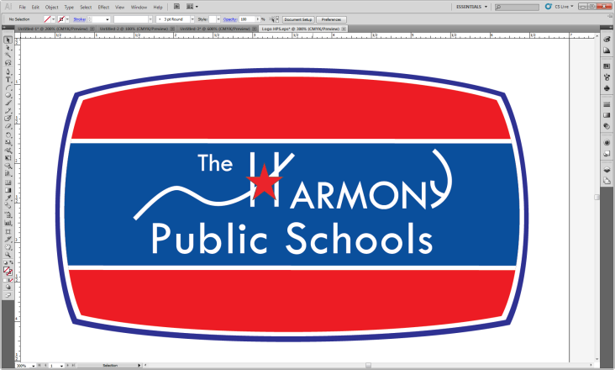 | 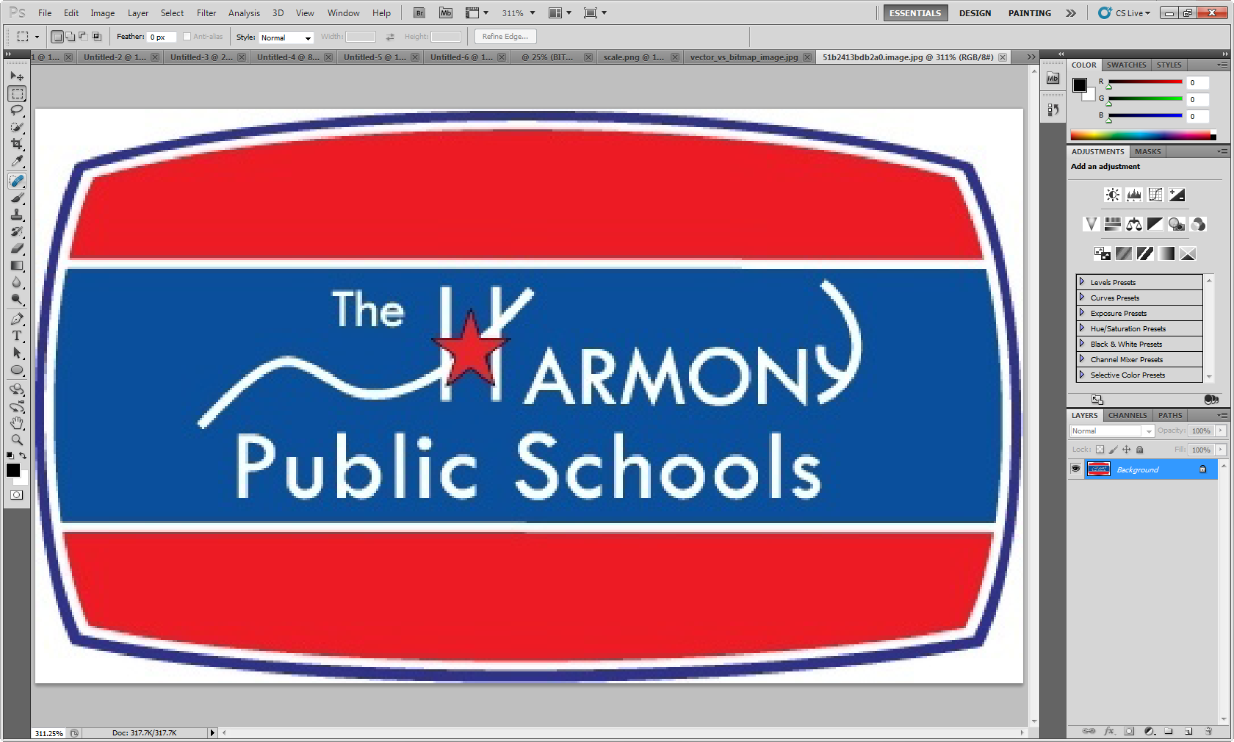
Bitmap | Vector
Bitmap | Vector
My Web | My Video

